**Grove - 4-Digit Display**

窗体顶端

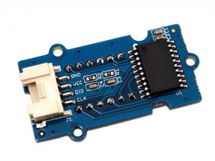

http://www.seeedstudio.com/depot/includes/templates/pure_green/images/next_l.gif

* [http://www.seeedstudio.com/depot/bmz_cache/b/b694fe84ceac06a70c93c473de4cc7bd.image.55x41.jpg](http://www.seeedstudio.com/depot/images/product/4-Digital%20Display.jpg)
* [http://www.seeedstudio.com/depot/bmz_cache/4/439dbc026bbcd7934b0a12e80bc3c081.image.55x41.jpg](http://www.seeedstudio.com/depot/images/product/4-Digital%20Display_01.jpg)

http://www.seeedstudio.com/depot/includes/templates/pure_green/images/next_r.gif

* **Price:**

$7.20  [(Price Feedback)](javascript:void())

* **SKU:**

LED05291P

* **Weight:**

8Gram

* **Units in Stock**

7

* **Designed by:**

[Seeed Studio](http://www.seeedstudio.com/)

* **Demension**
* **4.2*2.5**

[Other products from designer](http://www.seeedstudio.com/depot/seeed-studio-m-23.html)

* **Quantity:** Max: 7  
  
* [Add to Wish List](http://www.seeedstudio.com/depot/index.php?main_page=un_wishlist&products_id=1198&cPath=156_157&action=un_add_wishlist)

Description

4 digit display module is usually a 12 pin module. In this Grove gadget, we utilize a TM1637 to scale down the controlling pins into 2 Grove pins. It only takes 2 digital pins of Arduino or Seeeduino to control the content, even the luminance of this display. For projects that require of alpha-numeric display, this can be a nice choice.

**Features**

* 4 digit red alpha-numeric display
* Grove compatible
* 8 adjustable luminance levels

**Application Ideas**

* Time display
* Stopwatch
* Sensors’ input display

**Documents**

Please visit our [wiki](http://www.seeedstudio.com/wiki/Grove_-_4-Digit_Display) page for more info about this product. It will be appreciated if you can help us improve the documents, add more demo code or tutorials. For technical support, please post your questions to our[forum](http://forum.seeedstudio.com/).

窗体底端